

MGSC 672: Operations and Supply Chain Analytics
Case Study #2: JOANN Analytics Inventory Allocation Tool

Submitted to:
Professor Saibal Ray

Submitted by:
Group 4
Luice Peccoux | 261087292
Julie Chanzy | 261077392
Priyanka Jahul | 261076605
Emery Dittmer | 260658030
Sunny Wu | 261102578
Michael Murphy | 261060598

May 24th, 2023

Executive Summary
This case study analyses the adoption of JIAT, an inventory allocation tool, at JOANN, a leading company in the U.S. fabric, crafting and sewing supplies segment, and its impact on the past Halloween sale. Before the implementation of JIAT, allocation analysts manually allocated inventory for in-season products, the tool was introduced to improve the allocation process efficiency, accuracy, and responsiveness to in-season demand trends. However, the implementation of JIAT also introduced some problems, critically an inaccurate demand forecasting and inventory allocation, leading to overtime hours, forced markdown and frustration during the past Halloween season.
The VP of inventory management at JOANN, Joyce, needs to decide whether to continue using JIAT or not. Considering the recent issues and upcoming Christmas sale Joyce will evaluate the current problems imposed by JIAT, the potential options to tackle the issues, and decide whether or not to change back to manual forecasting.
We recommend JOANN pursue JIAT improvements and updates but not for the upcoming Christmas season. We will examine and detail the problems associated with JIAT adoption and provide recommendations to address these issues from a technical and process angle. These two different angles highlight the corresponding limitations to planning for the future of upcoming season sales and future inventory management at JOANN.

Problem Presentation & Analysis
This use case presents inventory allocation and demand prediction via the former manual approach and new JIAT allocation methods at JOANN. Previously, allocation analysts manually predicted forecasts and allocation. However, this process took time and needed to be more accurate than a data-driven approach, even more with seasonal products. Indeed, for those kinds of items, JOANN has a limited inventory to distribute throughout its stores as the delivery time from the manufacturers is too important. Additionally, many of the seasonal products are new items that JOANN has yet to sell. Their new allocation tool, JIAT, eases the process by allowing automated allocation decisions on the SKU level. Using JIAT has been a life-changing experience for the allocation analysts, reducing the usual one-month period to make the forecast and allocations to just one week. The rapid and accurate forecasting of the tool also led the analysts to go from monthly allocation to weekly allocation, allowing them to be more reactive to seasonal change, a real advantage for seasonal products. At the end of the Halloween season, the use of JIAT showed some good performances: fewer stockouts, a decrease in labour cost (fewer products left on the shelves at the end of the event), and an increase in the sell-through (from 78 to 86%).
However, JIAT failed to meet all the expectations, raising concerns on various fronts. It did not adhere to the designated constraints, as only 47% of the Halloween inventory was allocated at the beginning of the season instead of the expected 60%. There was also a notable increase in markdowns, rising from 14% to 18%, as well as a rise in supply chain costs due to overtime and more expensive transportation caused by the weekly allocation process. Moreover, a portion of the inventory in the distribution centers remained unallocated at the end of the season, a situation that had not occurred previously. After an investigation, Joyce discovered that these problems were directly linked to the tool and uncovered several key issues.
First, JAIT resolves a linear programming problem (LP) for inventory allocation, but if there are no solutions to the problem, then the model is unfeasible. If JIAT encounters an unfeasible error, the tool stops, leaving the inventory unallocated. Then, allocation analysts must manually allocate inventory way or force different parameters. Returning to doing things manually led to an increase in the processing time, which was incompatible with the new weekly allocation. Changing the parameters skewed the LP results, limiting any optimal allocation of the remaining inventory. Both situations resulted in insufficient SKU allocations and inventory left in the distribution centers.
Next Joyce found that the tool's underlying logic contains a critical issue: it consistently recommends an allocation total lower than the input target quantity, resulting in inaccurate allocation. Analysts have yet to uncover this problem because of the complex nature of the tool. This revelation imposes a question about the previous allocations and a potential risk for future uses of JIAT. If the allocation is inaccurate and no one notices, what are the risks to the business and sell-through rates? Therefore, model explainability is crucial.
Finally, the tool needs better user experience design. Users have reported difficulty navigating the tool interface and encountering unclear error messages. These shortcomings can be attributed to a lack of consideration for creating a user-centric design, as well as a failure to provide adequate user training, error handling or guide documents prior to using the tool.

Now that Joyce has done a descriptive analysis, he needs to decide if the problems are fixable and whether to pursue the use of JIAT for the Christmas season and so on.

Detailed Recommendations & Impact
The problems that JIAT caused can be addressed by careful management and improvements. Our recommendations for this situation are two-fold: continue using the tool by fixing the tool’s code and improving the process with which the tool operates. The tool’s inaccuracy is forcing JOANN to have additional cost and work. In addition, the operations team operates biweekly while the tool predicts weekly. Therefore, the process itself needs some restructuring to address these issues. We recommend Joyce adopt an agile methodology to accelerate development and operate collaboratively to rebuild trust.
Joyce should start with fixing the tool. We recommend that the tool continues to be used as JOANN will require a technologically augmented method of decision-making and forecasting. The company has long ordering lead times (often 2 months or more) and can only store inventory for a short time. Joyce should first understand the causes of the errors detected. Some issues will be fixed by updating the software to avoid errors and font load inventory management.
To further update the tool, developing an intuitive user interface and user experience will be crucial to empower employees with a user-friendly tool they want to use. Fields filled by default, a semi-automated process, and a clear default value in case of errors are key ways to fix the issues. Once implemented, these changes will help avoid the pitfalls of the Halloween season, where no default logic exists, and the lack of clear understanding of error codes leads to wasted time and mistrust of the tool.
User acceptance testing (UAT) is strongly recommended to implement changes and regular updates. UAT allows Joyce to gather qualitative and quantitative feedback on the tool’s usage and performance. UAT would help make the tool more intuitive and efficient. A draft UAT framework is available in exhibit 1 for reference. An adequate feedback loop between inventory managers, inventory allocation analysts and the IT department to fix errors quickly should be implemented; for example, a collaborative project management tool such as jira augments communication between inventory analysts and developers.

After examining the recommendations above and the literature, we estimate that by fixing the inventory allocation tool and optimizing predictions, JOANN could save up to 30% on each SKU through decreased inventory costs, transportation costs and more flexibility in markdown strategies.¹
These recommendations must also address this case's process or more human aspects. We examine the current state process in exhibit 2. After resolving most issues with the tool, the IT department should host a training day to bridge the user knowledge gap. Training helps answer technological difficulties and gives more autonomy to employees. Standard procedures should be discussed and required in the case of an error message from the system. For example, distribution centers could implement an automated alert based on low inventory levels or to push all remaining inventory to stores before the end of the season; employees could also refer to standard business best practices in case of unexpected events to ensure no sitting inventory, shipping over stacking or delays. These business rules would help with edge cases where the tool does not accurately predict inventory needs. Clearly defining the expectations, objectives, and key performance indicators for each chain actor would contribute to monitoring the process and controlling the logistic cost generated by the tool migration.
Last, it is essential to reinforce communication between business units, as the supply chain cannot exist in a vacuum. As illustrated by some of the employees' testimonies, there are very few, if any, interactions between distribution centers and stores, thus creating opacity and confusion in the company. Employees should be able to inform or be informed of difficulties in the supply chain that impact their activity. Using the tool with communication software like Jira will create a common understanding of inventory needs throughout the organization. These changes are summarized in exhibit 2. Communication is vital, as well as trust in the process. Following a progressive and agile implementation will contribute to the latter, starting with an A/B testing of the tool at the SKU level to smooth handover to inventory and merchandising managers.

Limitations
In today’s evolving business landscape, companies implementing process improvements (especially switching from manual to technological advancements) tend to gain a more competitive edge. Investing in JIAT is crucial for a competitive advantage. Automation saves time, some use cases demonstrate an 87% time savings through automation. ² Even gains of 5% translate to millions of dollars and hours saved. While it is true that a strategy which requires augmenting the capabilities of the JIAT tool is likely to incur costs at the beginning, this can bring long-term benefits. Manual errors will be reduced, and efficiency will be enhanced, enabling the company to save time and resources in the long run. However, this would remain a considerable investment for the company, and a tough decision will have to be made about whether the outcome is worth it or not in this case.
Even if the company managed to come up with and implement a strategy to fix JIAT before Christmas, there are still many risks that come with using a tool without proper testing and validation n. Christmas is a crucial period for retailers, with high customer expectations and intense competition. Some retailers make 1/3 of their annual revenue during this period. ³ In the short term, if the new inventory allocation strategy fails to meet customer demands or results in inadequate stock levels, the company may miss out on significant sales opportunities that are difficult to recover. In the long term brand reputation may be damaged. If the new strategy leads to product unavailability, delays, or unsatisfactory customer experiences, it can harm the company’s reputation and result in customer dissatisfaction, potentially affecting future sales and customer loyalty. Using JIAT prematurely has significant repercussions.
The case for JIAT is strong, but JOANN must weigh the costs and benefits of its usage. This includes considering whether the tool will ultimately prove helpful for the company. First, will the time employees spend mastering this tool be offset by time gains in the future? Second, will the costs of maintaining this tool over time prove too high? Lastly, what are the cost implications of inaccurate manual forecasting versus inaccurate JIAT forecasting? Overestimates lead to underutilized resources and waste, while underestimations increase overtime and last-minute freight costs. JOANN should invest in JIAT, data expertise and a data-driven future.

References
(1) Martínez, K. K. Y. C. a. J. Cost Savings Through Effective Inventory Management. Supply Chain Management Review 2019.

(2) Dataiku. Bankers’ Bank + Dataiku: Goodbye Data Silos, Hello Analytics Efficiency. 2019.
(3) Richter, F. How Important is the Holiday Season for Retailers? . Statista, 2022.

Appendix
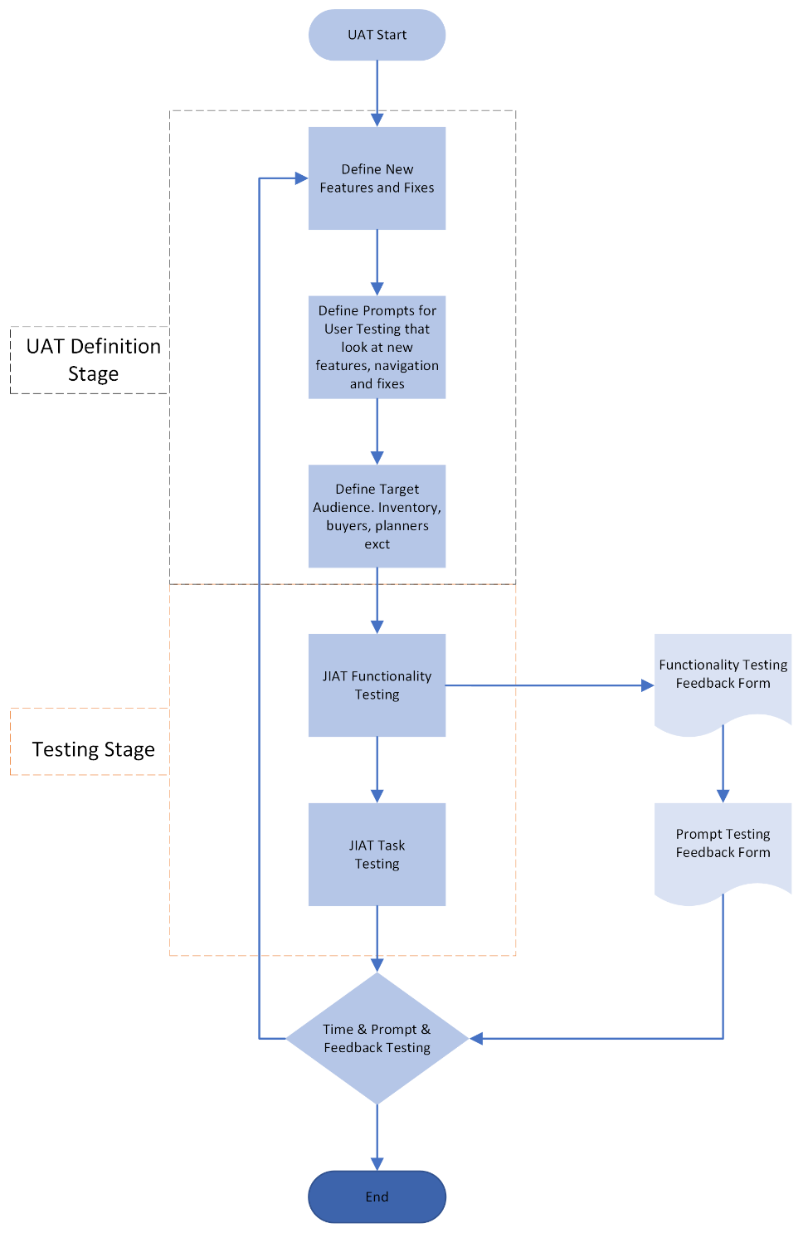
Feedback Type | Link
JIAT UAT Task Feedback Form | Link here
JIAT UAT Functionality Feedback | Link here

Exhibit 1:User Acceptance Testing Flow Chart for Implementing JIAT Fixes. Included are basic UAT forms and methods to build off of

Present State Operations | Future Proposed Operations
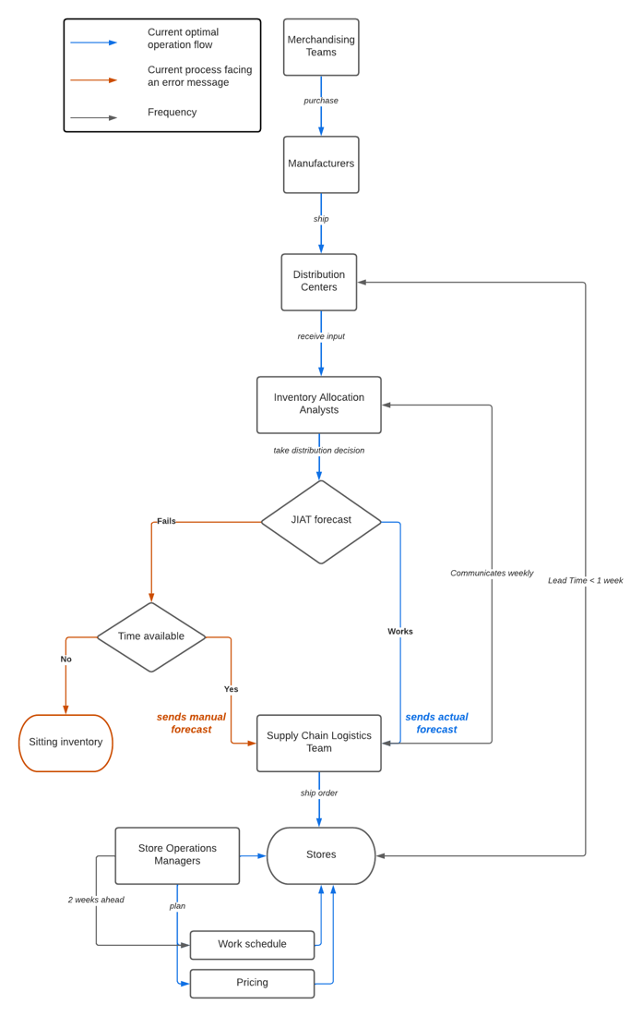 | 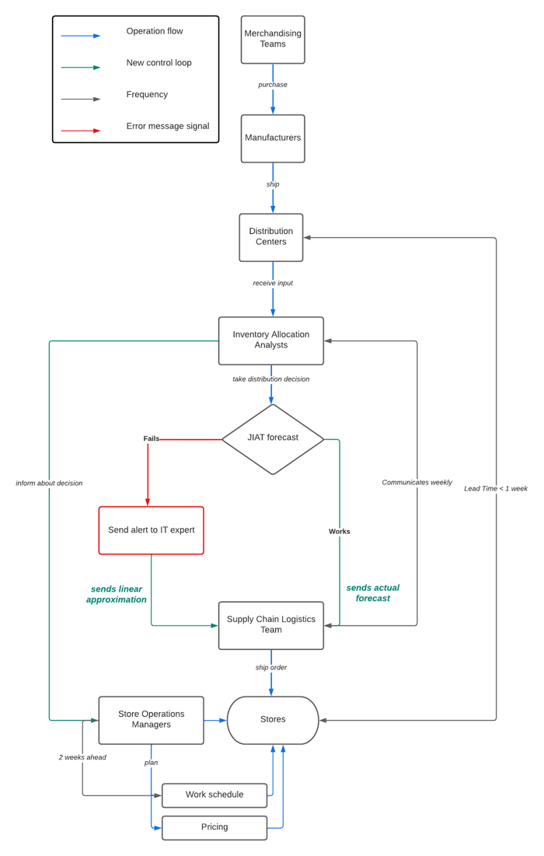
Exhibit 2: Comparison of Current State Inventory Allocation (left) vs. Proposed Future State (Right) with JIAT for JOANN. Note new controls and processes.

